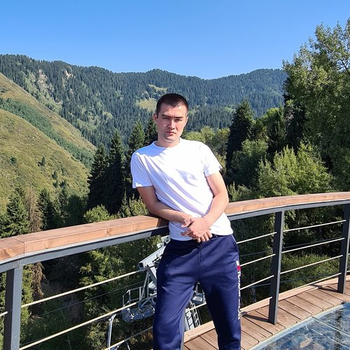 |  | Syrymbet Daulet  +7 (707) 4000810  daulet.sdn@gmail.com  Location: Almaty
Work experience
June 2022 — current time |  | Eurasian bank  eubank.kz  Java-developer  Java, Spring Boot, Keycloak, Zeebe
April 2019 — May 2022 |  | Prime Source, ТОО  Алматы, www.primesource.kz  Java-developer  Java, Spring Boot, Rabbit
January 2018 — March 2019 |  | Nursat plus  Web-developer  React Redux, Node js
Education
Bachelor
2014 |  | Almaty University of Telecommunication and Power
Skills
Languages |  | Kazakh — native  Russian — fluent  English — intermediate
Skills |  | OOP Java 11 SQL Spring Boot Git Java PostgreSQL Docker Golang Keycloak

